Invitation Template for
Parent/Caregiver Vision Social or Vision Meeting
Add your own text (e.g., food and child care will be available; you are doing a snack share, door prizes – playing games [experiential activities])
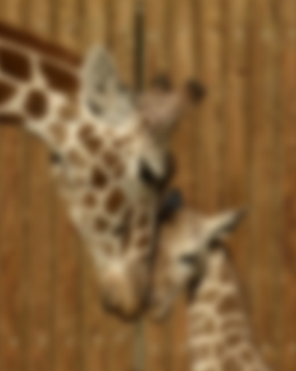
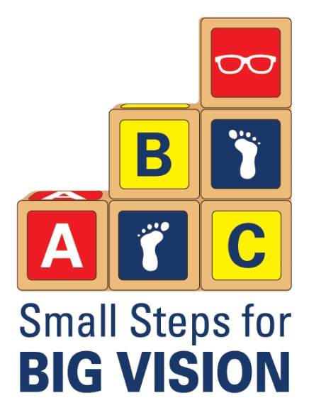
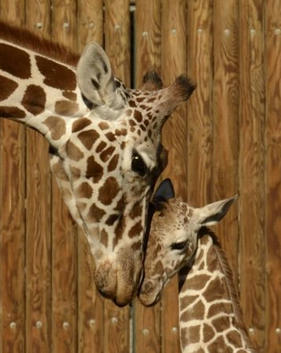

We can’t see how kids can’t see.

Your child’s vision could be clear like the 1st picture . . . or blurry like the 2nd picture . . .

- Come learn how blurry vision could impact your child’s learning, behavior, and development.

- Learn how to care for your own vision.

WHEN:

WHERE:

TIME:
